|  |  |
| --- | --- |
| **1.** | **What is Keyboard? How it works?** |
|  | * A keyboard is the set of typewriter-like keys that enables you to enter data into a computer. * Computer keyboards are similar to electric-typewriter keyboards but contain additional keys. * The keys on computer keyboards are often classified as follows:   + ***Alphanumeric keys***– letters and numbers   + ***Punctuation keys*** – comma, period, semicolon, and so on.   + ***Special keys*** – function keys, control keys, arrow keys, Caps Lock key, and so on. * The processor in the keyboard analyzes the key matrix and determines what characters to send to the computer. * It maintains these characters in its **memory buffer** and then sends the data. * Many keyboards connect to the computer through a cable with a PS/2 or USB (Universal Serial Bus) connector. * Regardless of which type of connector is used, the cable must carry power to the keyboard, and it must carry signals from the keyboard back to the computer. * Wireless keyboards, on the other hand, connect to the computer through **infrared** (IR), **radio**   frequency (RF) or **Bluetooth** connections.   * IR and RF connections are similar to what you'd find in a remote control. * Regardless of which sort of signal they use, wireless keyboards require a **receiver**, either built in or plugged in to the USB port, to communicate with the computer. * Since they don't have a physical connection to the computer, wireless keyboards have an AC power connection or use batteries for power. * Whether it's through a cable or wireless, the signal from the keyboard is monitored by the computer's **keyboard controller**. * Keyboard controller is an integrated circuit (IC) that processes all of the data that comes from the keyboard and forwards it to the operating system. |
| **2.** | **Explain in detail different types of Keyboard.** |
|  | **1) PC-XT Keyboard**     * This keyboard has only one side communication. The keyboard can send information to the system but the system was not allowed to send any information or command to the keyboard. * Number of Keys: 83 * Mode of Communication: Unidirectional * Size of Enter and Shift keys were small. * Keys were marked with arrows instead of word describing them * No indicators to show status of num_lock, caps_lock and scroll_lock |

|  |  |
| --- | --- |
|  | **2) PC-AT Keyboard**     * Number of Keys: 84 * Mode of Communication: Bidirectional * Numeric keypad moved away from alphabet keys * Indicators available to show status of num_lock, caps_lock and scroll_lock * Size of Enter and Shift keys is increased and word “Enter” is printed on the key top. * Most of the keys that were indicated only with arrow symbols were also indicated with sort word describing them.   **3) Enhanced PC-AT Keyboard**     * Number of Keys: 101 * Additional navigation and control keys * 12 function keys in separate row along top were provided * The size of “Enter” key is reduced to a small size * Provided additional CTRL and ALT keys on both sides of space bar for easy access |
| **3.** | **Explain in detail layout of keyboard** |
|  | * **A computer keyboard comprises**   + Alphanumeric or character keys for typing,   + Modifier keys for altering the functions of other keys,   + Navigation keys for moving the text cursor on the screen,   + Function keys,   + System command keys – such as “Esc” and “Break” – for special actions, and   + Numeric keypad to facilitate calculations. * There is some variation between different keyboard models in the mechanical layout – i.e., how many keys there are and how they are positioned on the keyboard. |

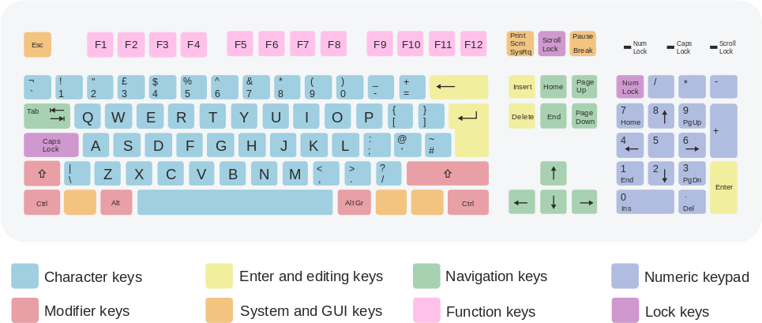

## Character Key or Alphabet Key

* The core section of a keyboard comprises character keys, which can be used to type letters and other characters.
* Typically, there are three rows of keys for typing letters and punctuation, an upper row for typing digits and special symbols, and the Space bar on the bottom row.
* The positioning of the character keys is similar to the keyboard of a typewriter.

## Modifier Key

* Besides the character keys, a keyboard incorporates special keys that do nothing by themselves but modify the functions of other keys.
* For example, the ⇧ Shift key can be used to alter the output of character keys, whereas the ^ Ctrl (control) and ^ Alt (alternate) keys trigger special operations when used in concert with other keys.
* Typically, a modifier key is held down while another key is struck.

## Cursor Movement Key

* Cursor movement arrows are provided in the middle of alphabet and numeric keys.
* Two rows with group of three keys include Insert, Delete, Home, End, Page Up and Page Down keys are provided just above the cursor movement keys.
* When “Num Lock” indicator is off, then the numeric key pad is used as cursor movement key.

## Function Key

* Function keys from F1 to F12 are spaced in group of four on the topmost area of keyboard
* They don’t have fixed purpose and the user can assign function to these keys by programming.
* e.g. F1 is used to show help message / help content on screen.

# Explain in detail different types of keyboard interfaces. OR

**Explain in detail different types of keyboard interface connector.**

* + The keyboard connector is the device at the end of the cable that is used to attach the keyboard to the system.

**Wired keyboard**

## DIN

* + The older style is the larger of the two, called the 5-pin DIN keyboard connector.
  + DIN stands for Deutsche Industries Norm, a German standards-setting organization.
  + 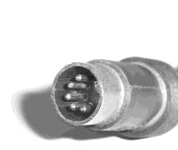It was used on the first PCs, and became the standard connection through about the mid- 1990s.

|  |  |  |
| --- | --- | --- |
| **Pin** | **Description** | **Image** |
| 1 | Keyboard Clock |  |
| 2 | Keyboard Data |
| 3 | Not Connected |
| 4 | Ground |
| 5 | Power (+5 V) |
| 6 | - |

## PS/2

* + The smaller is the 6-pin, so-called "mini-DIN" keyboard connector.
  + The smaller connector was introduced on the IBM model PS/2 and is therefore sometimes called a "PS/2 connector".
  + It has replaced the larger connector as the standard for modern PCs.

|  |  |  |
| --- | --- | --- |
| **Pin** | **Description** | **Image** |
| 1 | Keyboard Data |  |
| 2 | Not Connected |
| 3 | Ground |
| 4 | Power (+5 V) |
| 5 | Keyboard Clock |
| 6 | Not Connected |

## USB

* + USB, or Universal Serial Bus, is the most common type of interface and has become the standard interface on all current computers.
  + One of the benefits of a well-defined specification like the USB is the abundance of device drivers available in most modern operating systems.
  + Because of these generic descriptions, it is easy for operating system designers to include functioning drivers for devices such as keyboards, mice, and other generic human interface devices.

|  |  |  |
| --- | --- | --- |
| **Pin** | **Description** | **Image** |
| 1 | Power (+5 V) |  |
| 2 | Data - |
| 3 | Data + |
| 4 | Ground |

**Wireless Keyboard**

* + A wireless keyboard is a computer keyboard that allows the user to communicate with computers, tablets, or laptops with the help of radio frequency (RF), infrared (IR) or Bluetooth technology.
  + Wireless keyboards based on infrared technology use light waves to transmit signals to other infrared-enabled devices.
  + But, in case of radio frequency technology, a wireless keyboard communicates using signals which range from 27 MHz to up to 2.4 GHz.
  + Most wireless keyboards today work on 2.4 GHz radio frequency.
  + Bluetooth is another technology that is being widely used by wireless keyboards.
  + These devices connect and communicate to their parent device via the Bluetooth protocol.
  + A wireless keyboard can be connected using RF technology with the help of two parts, a transmitter and a receiver.
  + The radio transmitter is inside the wireless keyboard.
  + The radio receiver plugs into a keyboard port or USB port.
  + Once the receiver and transmitter are plugged in, the computer recognizes the keyboard and mouse as if they were connected via a cable.

# Explain in detail different types of Keyboard Switches

* + Computer keyboards can be classified by the switch technology that they use.
  + Computer keyboards have 80–110 durable switches, one for each key.
  + The choice of switch technology affects key response (the positive feedback that a key has been pressed) and travel (the distance needed to push the key to enter a character reliably).

## Capacitive Switch

* + Current constantly flows through all parts of the key matrix.
  + Each key is spring-loaded and has a tiny plate attached to the bottom of it.
  + When you press a key, it moves this plate closer to the plate below it.
  + As the two plates move closer together, the amount of current flows through the matrix changes.
  + The processor detects the change and interprets it as a key press for that location.
  + Capacitive switch keyboards are expensive, but they have a longer life than any other keyboard.
  + Also, they do not have problems with bounce since the two surfaces never come into actual contact.

## Hall Effect Switch

* + 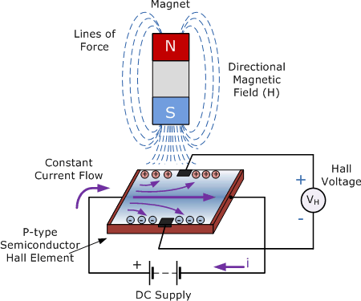Hall Effect keyboards use magnets and Hall Effect sensors instead of an actual switch.
  + When a key is depressed, it moves a magnet, which is detected by the solid-state sensor.
  + These keyboards are extremely reliable, and are able to accept millions of keystrokes before failing.
  + These keyboards can be easily made totally waterproof.
  + They also resist large amounts of dust and contaminants.
  + Because a magnet and sensor are required for each keys, and custom control electronics, they are very expensive.

## Dome-Switch

* + Dome switch uses small, flexible rubber domes, each with a hard carbon center.
  + When you press a key, a plunger on the bottom of the key pushes down against the dome, the carbon center presses against a hard, flat surface beneath the key matrix.
  + As long as the key is held, the carbon center completes the circuit.
  + When the key is released, the rubber dome springs back to its original shape, forcing the key back up to its at-rest position.
  + Rubber dome switch keyboards are inexpensive, have pretty good tactile response
  + Switches are fairly resistant to spills and corrosion because of the rubber layer covering the key matrix.

## Membrane Switch

* + A membrane keyboard is a computer keyboard whose "keys" are pressure pads that have only outlines and symbols printed on a flat, flexible surface.
  + Membrane keyboards, which work by electrical contact between the keyboard surface and the underlying circuits when key-top areas are pressed, were used with some early 1980s.
  + The keyboards are very inexpensive to mass-produce, and are more resistant against dirt and

|  |  |
| --- | --- |
|  | liquids than most other keyboards.   * The membrane keyboard basically consists of three layers; two of These are membrane layers containing conductive traces. * The center layer is a "spacer" containing holes wherever a "key" exists. It keeps the other two layers apart.      * Under normal conditions, the switch (key) is open, because current cannot cross the non- conductive gap between the traces on the bottom layer. * However, when the top layer is pressed down (with a finger), it makes contact with the bottom layer. * The conductive traces on the underside of the top layer can then bridge the gap, allowing current to flow. * The switch is now "closed", and the parent device registers a key-press.   **E) Mechanical Switch**     * The pure mechanical type is a simple mechanical switch that features metal contacts in a momentary contact arrangement. * The switch often includes a feedback mechanism, consisting of a clip and spring arrangement designed to give a "clicky" feel to the keyboard and offer some resistance to the key-press. * Mechanical switches are very durable, usually have self-cleaning contacts, and are normally rated for 20 million keystrokes. |
| **6.** | **Explain in detail Keyboard organization in detail.** |
|  | * With a matrix circuit, any of 61 notes can be determined with only 16 wires. * This is drawn schematically as a matrix of 8 columns and 8 rows of wires, with a switch at every intersection. * The keyboard controller scans the columns. * If a key has been pressed, the controller scans the rows. * The controller determines the row-column combination at which a key has been pressed, and generates a note corresponding to that key. |

|  |  |
| --- | --- |
|  | **Debouncing**   * When striking a keyboard key, the key oscillates (or bounces) against its contacts several times before settling. * When released, it oscillates again until it reverts to its rest state.      * Although it happens on such a small scale as to be invisible to the naked eye, it's sufficient for the computer to register multiple key strokes inadvertently. * To resolve this problem, the processor in a keyboard "debounces" the keystrokes * By aggregating them across time to produce one "confirmed" keystroke that (usually) corresponds to what is typically a solid contact   **Scan Code**  Each key generates a 'make' scancode when pressed and a 'break' scancode when released. The computer system interprets the scancodes to determine what operation it is to perform. **How to Calculate the Scancode**   * Use the keyboard sketches to determine the 'Key Number'. * Lookup the 'Key number' in the table. * Read of the 'Make'scancode. * Note that the scancode differs depending on the scancode set currently in use. * Calculate the 'break' scancode as detailed below   + The 'break' code for AT class scancodes is simply the 'make' code proceeded by hex F0.   + For example the scancodes generated when the Escape key is pressed and released are 76 F0 76. |
| **7.** | **Explain in detail different types of Mouse.** |
|  | * A mouse is an input device that detects two-dimensional motion relative to a surface. * This motion is typically translated into the motion of a pointer on a display, which allows for fine control of a graphical user interface. * A mouse consists of an object held in one's hand, with one or more buttons. * Mice often also feature other elements, such as touch surfaces and "wheels", which enable extra control and dimensional input. * ***Three*** basic types of mouse:   o **Mechanical**: Has a rubber or metal ball on its underside that can roll in all directions. Mechanical sensors within the mouse detect the direction the ball is rolling and move the  screen pointer accordingly. |

* + - 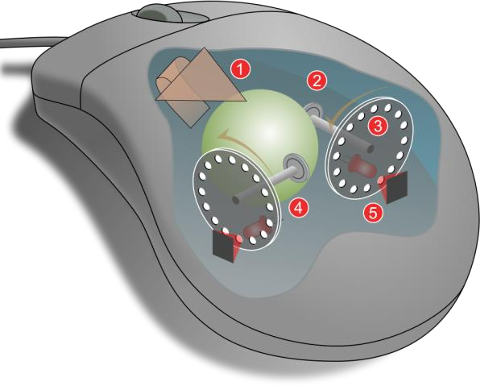**Optomechanical**: Same as a mechanical mouse, but uses optical sensors to detect motion of the ball.
    - **Optical**: Uses a laser to detect the mouse's movement.

You must move the mouse along a special mat with a grid so that the optical mechanism has a frame of reference.

Optical mice have no mechanical moving parts.

They respond more quickly and precisely than the other two type, but they are also more expensive.

# Explain in detail different types of Mouse interface.

## Serial Port Mouse

* + A serial port is a serial communication physical interface through which information transfers in or out one bit at a time.
  + A mouse that connects to a computer via a serial port is serial port mouse.
  + 9-pin connector is used to connect mouse.

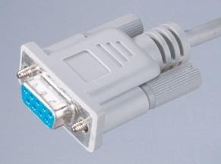

## PS/2 Port Mouse

* + The PS/2 connector is a 6-pin Mini-DIN connector for connecting mice to computer system.
  + They are not designed to be hot swappable.
  + It is necessary to restart a PC when you connect mouse to computer when it is on.

|  |  |  |
| --- | --- | --- |
| **Pin** | **Description** | **Image** |
| 1 | Keyboard Data |  |
| 2 | Not Connected |
| 3 | Ground |
| 4 | Power (+5 V) |
| 5 | Keyboard Clock |
| 6 | Not Connected |

## USB Port Mouse

* + USB, or Universal Serial Bus, is the most common type of interface and has become the standard interface on all current computers.
  + One of the benefits of a well-defined specification like the USB is the abundance of device

drivers available in most modern operating systems.

* + Because of these generic descriptions, it is easy for operating system designers to include functioning drivers for devices such as keyboards, mice, and other generic human interface devices.

|  |  |  |
| --- | --- | --- |
| **Pin** | **Description** | **Image** |
| 1 | Power (+5 V) |  |
| 2 | Data - |
| 3 | Data + |
| 4 | Ground |

## Wireless Mouse

* + A wireless mouse is a computer mouse that needs no wires to send signals from the mouse to a computer.
  + The cordless mouse offers obvious advantages over its tethered brethren, such as being able to point and click on a computer screen from across the room and run on multiple surfaces.
  + Being radio-based, RF devices require two main components: a ***transmitter*** and a ***receiver***.
  + One of the RF technologies that wireless mice commonly use is Bluetooth.
  + Bluetooth technology wirelessly connects peripherals such as printers, headsets, keyboards and mice to Bluetooth-enabled devices such as computers and personal digital assistants (PDAs).

## How it works?

* + - * The transmitter is housed in the mouse.
      * It sends an electromagnetic (radio) signal that encodes the information about the mouse's movements and the buttons you click.
      * The receiver, which is connected to your computer, accepts the signal, decodes it and passes it on to the mouse driver software and your computer's operating system.
      * The receiver can be a separate device that plugs into your computer, a special card that you place in an expansion slot, or a built-in component.

# Explain in detail Mouse operation

* + A mouse typically controls the motion of a pointer in two dimensions in a graphical user interface (GUI).
  + The mouse turns movements of the hand backward and forward, left and right into equivalent electronic signals that in turn are used to move the pointer.
  + Clicking or hovering (stopping movement while the cursor is within the bounds of an area) can select files, programs or actions from a list of names, or (in graphical interfaces) through small images called "icons" and other elements.

### Click: pressing and releasing a button.

* + (left) Single-click: clicking the main button.
  + (left) Double-click: clicking the button two times in quick succession count as a different gesture than two separate single clicks.
  + (left) Triple-click: clicking the button three times in quick succession.
  + (left) Quadruple-click: clicking the button four times in quick succession.
  + Right-click: clicking the secondary button.
  + Middle-click: clicking the tertiary button.

|  |  |
| --- | --- |
|  | **Drag: pressing and holding a button, then moving the mouse without releasing. Button**  **chording**   * Combination of right-click then left click. * Combination of left-click then right-click or keyboard letter. * Combination of left or right-click and the mouse wheel. * Clicking while holding down a modifier key.   **Moving the Pointer a long distance:**   * When a practical limit of mouse movement is reached, one lifts up the mouse brings it to the opposite edge of the working area while it is held above the surface and then replaces it down onto the working surface |
| **10.** | **Explain in detail different types of Scanners.** |
|  | **A) Flatbed scanners**   * Flatbed scanners also called desktop scanners are the most versatile and commonly used scanners.   **B) Sheet-fed scanners**   * These are similar to flatbed scanners except the document is moved and the scan head is immobile. * A sheet-fed scanner looks a lot like a small portable printer.   **C) Handheld scanners**   * It use the same basic technology as a flatbed scanner, but rely on the user to move them instead of a motorized belt. * This type of scanner typically does not provide good image quality. However, it can be useful for quickly capturing text.   **D) Drum scanners**   * These are used by the publishing industry to capture incredibly detailed images. * They use a technology called a photomultiplier tube (PMT). * In PMT, the document to be scanned is mounted on a glass cylinder. * At the center of the cylinder is a sensor that splits light bounced from the document into three beams. Each beam is sent through a color filter into a photomultiplier tube where the light is changed into an electrical signal. |
| **11.** | **Explain the working of windows scanner OR**  **Explain the working of TWAIN & WIA scanner** |
|  | **TWAIN**   * You can use it to scan directly into any software application that supports TWAIN, for example a raster to vector conversion program. * This means that after you scan, the scanned image will appear in the application already open. * When you scan using an application that supports TWAIN, the scanning dialog and the options it contains are specified by your scanner’s manufacturer (Canon, Epson, HP, Contex , Graphtec etc.) and will therefore vary depending on the type of scanner you have.   **WIA (Window Image Acquition)**   * WIA (Window Image Acquition) is a Microsoft utility that is supplied as part of windows. * Like TWAIN; WIA allows you to scan directly with a “WIA compliant” scanner into any application that supports WIA or TWAIN – all TWAIN compliant application support WIA as   well. |

|  |  |
| --- | --- |
|  | * Unlike TWAIN, however, the scanning dialog that appears when you scan and the controls on it are variations on a basic Microsoft design. * This means that the level of functionality and scanning control that are available in a WIA interface are less comprehensive than in a well-written TWAIN interface. |
| **12.** | **Explain different types of printer with its working.** |
|  | **Printer**  A printer is a peripheral which makes a representation of an electronic document on physical media.  Individual printers are designed to support local and network users at the same time.  **Classification of Printer**   * Different method is used by different printers to produce the required output on the paper. * The quality and capability of the printing depends on the method used to generate the image or character by the printer. * Two possible image formation methods used by printer are * Based on the image formation method * Based on the printing mechanism used by printer   1. **Based on the image formation method Fully Formed Character Printer** * All the printable character are made in advance and provided in the printer as a part of printer hardware itself. * By pressing any key, one can get the shape printed on the paper. * This type of printer can only print ready-made characters on the paper, but not print any other character which is not stored inside its hardware. * Most of the fully formed character printer use impact method to print on the paper. * Due to this it can generate high noise. * Some of the fully formed character type printers are:   + Daisy-Wheel printer   + Chain printer   + Drum printer   **Bit Image Printer**   * The characters are formed from dots placed within a matrix. * It can be capable to print text as well as graphic image. * By controlling individual dots, computer can make these printers to produce any required pattern. * Some of the bit image printers are: * Dot matrix printer * Line printer   **B) Based on the printing mechanism used by printer**   * Printing mechanism refers to the method used by the printer to produce the image on the output media such as paper, OHP, etc. * Printer category based on the mechanism is classified as follow: * Impact Printer * Non-Impact Printer   **Impact Printer**   * An impact printer is a type of printer that operates by striking a metal or plastic head against an ink ribbon. * The ink ribbon is pressed against the paper, marking the page with the appropriate |

character, dot, line, or symbol.

* Common examples of impact printers include dot matrix, daisy-wheel printers, and ball printers.
* These printers are generally very low cost and easy to operate.
* It generates too much of noise while printing.

### Daisy Wheel Printer

* + It uses interchangeable pre-formed type elements to generate high-quality output.
  + The daisy wheel is considered to be so named because of its resemblance to the daisy flower.
  + 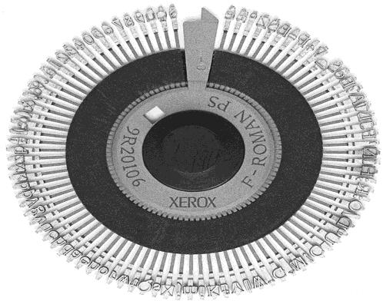The heart of the system is an interchangeable metal or plastic "daisy wheel" holding an entire character set as raised characters moulded on each "petal".
  + A servo motor rotates the daisy wheel to position the required character between the hammer and the ribbon.
  + The solenoid-operated hammer then fires, driving the character type onto the ribbon and paper to print the character on the paper.
  + The daisy wheel and hammer are mounted on a sliding carriage.
  + Different typefaces and sizes can be used by replacing the daisy wheel.
  + It is possible to use multiple fonts within a document.
  + Font changing is facilitated by printer device drivers which can position the carriage to the center of the platen and prompt the user to change the wheel before continuing printing.

1. **Line Printer**
   * The line printer is a form of high speed impact printer in which one line of type is printed at a time.
   * Print speeds of 600 to 1200 lines-per-minute.
   * The different types of line printers are drum printers and chain printers.

## Chain Printer

* + The chain spins horizontally around a set of hammers.
  + 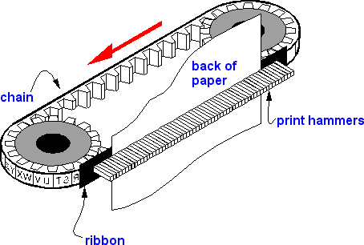When the desired character is in front of the selected print column, the corresponding hammer hits the paper into the ribbon and onto the character in the chain.

### Drum Printer

* + 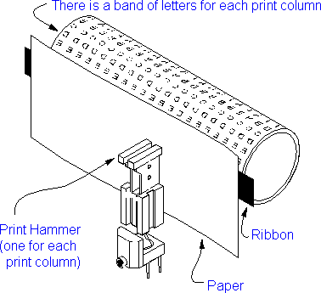In a typical drum printer design, a fixed font character set is engraved onto the periphery of a number of print wheels, the number matching the number of columns (letters in a line) the printer could print.
  + The wheels, joined to form a large drum (cylinder), spin at high speed and paper and an inked ribbon is stepped (moved) past the print position.
  + As the desired character for each column passes the print position, a hammer strikes the paper from the rear and presses the paper against the ribbon and the drum, causing the desired character to be recorded on the continuous paper.
  + Because the drum carrying the letterforms (characters) remains in constant motion, the strike-and-retreat action of the hammers had to be very fast.

### Dot Matrix Printer

* + Dot matrix printing or impact matrix printing is a type of computer printing which uses a print head that runs back and forth, or in an up and down motion, on the page and prints by impact, striking an ink-soaked cloth ribbon against the paper.
  + Each dot is produced by a tiny metal rod, also called a "wire" or "pin", which is driven forward by the power of a tiny electromagnet either directly or through small levers.
  + Facing the ribbon and the paper is a small guide plate pierced with holes to serve as guides for the pins.
  + 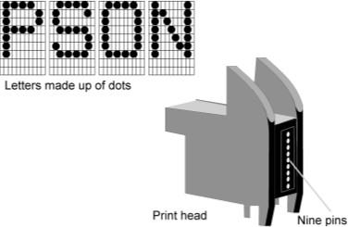The portion of the printer containing the pins is called the print head.
  + When running the printer, it generally prints one line of text at a time.
  + Such printers would have either 9 or 24 pins on the print head.
  + 24-pin print heads were able to print at a higher quality.
  + Feature:
    - Very simple operation
    - Low maintenance
    - Low operating cost
    - Provide facility to print on any type of paper
    - Faster than other impact printer

### Non-Impact Printer

* + The non-impact printer use ink spraying, electrostatic magnetization or heat process to produce the required image on the paper or any other output media.
  + This type of printers today becomes popular due to their soundless operation and very high quality output.

### Thermal Printer

* + Thermal printing (or direct thermal printing) is a digital printing process which produces a printed image by selectively heating coated thermochromic paper, or thermal paper as it is commonly known, when the paper passes over the thermal print head.
  + The coating turns black in the areas where it is heated, producing an image.
  + Two-colour direct thermal printers can print both black and an additional colour (often red) by applying heat at two different temperatures.
  + A thermal printer comprises these key components:
* Thermal head: generates heat; prints on paper
* Platen: a rubber roller that feeds paper
* Spring: applies pressure to the thermal head, causing it to contact the thermo sensitive paper
* Controller boards: for controlling the mechanism

### Inkjet Printer

* + An inkjet printer is any printer that places extremely small droplets of ink onto paper to create an image.
  + The core of an inkjet printer, the print head contains a series of nozzles that are used to spray drops of ink.
  + Depending on the manufacturer and model of the printer, ink cartridges come in various combinations, such as separate black and color cartridges, color and black in a single cartridge or even a cartridge for each ink color.
  + The cartridges of some inkjet printers include the print head itself.
  + A stepper motor moves the print head assembly (print head and ink cartridges) back and forth across the paper.
  + Some printers have another stepper motor to park the print head assembly when the printer is not in use.
  + Parking means that the print head assembly is restricted from accidentally moving.

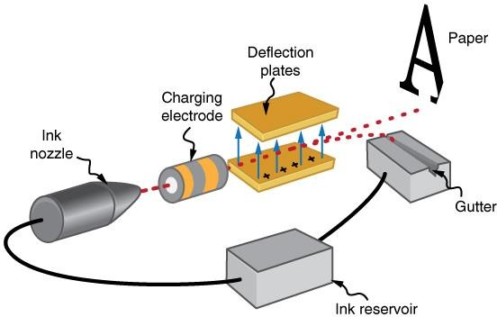

* + A belt is used to attach the print head assembly to the stepper motor.
  + The print head assembly uses a stabilizer bar to ensure that movement is precise and controlled.

|  |  |
| --- | --- |
|  | **3) Laser Printer**   * Laser printing is an electrostatic digital printing process * It rapidly produces high quality text and graphics by passing a laser beam over a charged drum to define a differentially charged image. * The drum then selectively collects charged toner and transfers the image to paper, which is then heated to permanently fix the image.      * A laser beam, typically from an aluminum gallium arsenide semiconductor laser, projects an image of the page to be printed onto an electrically charged rotating drum coated with selenium or, more common in modern printers, organic photoconductors. * Photoconductivity allows charge to leak away from the areas exposed to light. * Powdered ink (toner) particles are then electro statically picked up by the drum's charged areas, which have not been exposed to the laser beam. * The drum then prints the image onto paper by direct contact and heat, which fuses the ink to the paper. |
| **13.** | **Explain in detail printer interface** |
|  | * Printers are connected to computers using a variety of different interfaces such parallel, serial, SCSI, USB or IEEE 1394. * Network capable printers also have a built-in network interface and are connected directly to a port on the network so they can be shared across many computers.   **1) Parallel**     * A parallel printer interface is called (IEEE 1284). * This port works by sending an 8-bit information stream to the printer. It uses a standard parallel printer cable, which has a DB-25 connector to connect to the computer and also a 36-pin Centronics connector for the connection to the printer. * The maximum length of the parallel cable is usually limited to 10 feet. * The reason for this is that the data integrity decreases, and you can have loss of data to the printer over a larger length.   **2) Serial**   * The serial printer interface sends the data to the printer one bit at a time. * This interface needs to be configured to the serial communication parameters including |

baud rate, parity bit, or start and stop bits.

* + Serial printers are very rarely used these days, however sometimes dot matrix printers use this interface.

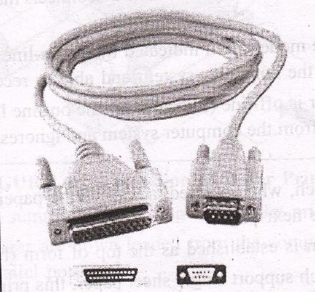

# Universal Serial Bus (USB)

* + The USB port is the most common type of port available on most pc today.
  + This is why it makes a great printer interface used on small and medium sized printers and desktop printers and scanners combos.
  + USB is much faster than most of the other types of printer interfaces.
  + A USB printer comes with Plug and play compatibility and can be automatically detected and configured by your operating system.

# IEEE 1394

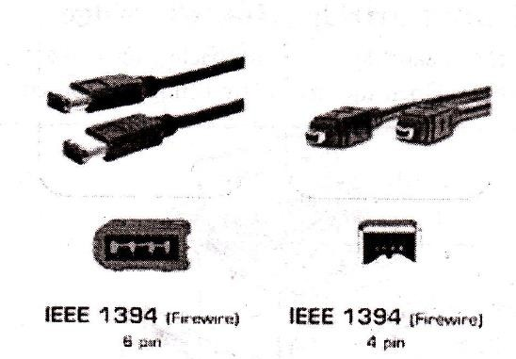

* + The IEEE 1394, which is also called Firewire, due the super fast speed that it boasted at when it was first released.
  + The firewire interface is not built in though on many printers or pc.
  + It is available for high end printers, and is popular on laptops.